# 

**AVENEL PRIMARY SCHOOL**

***OUR MISSION:***

To inspire academic excellence, social and emotional growth and community contribution in a collaborative environment.

Newsletter No: 30 4th October 2023

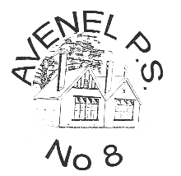

**Contact Details:**

**Web:** [**www.avenelps.vic.edu.au**](http://www.avenelps.vic.edu.au) **Email:** [**avenel.ps@education.vic.gov.au**](mailto:avenel.ps@education.vic.gov.au)

**Facebook:** [*https://www.facebook.com/Avenelprimary*](https://www.facebook.com/Avenelprimary)

**After Hours Number –** 0403 565 119



**Ross’ Report**

Welcome back to a busy and exciting term 4 at Avenel Primary School. It is always an action-packed term and this year will be no exception with Bike Hike, Energy Breakthrough, 3/4 Camp to Anglesea, the major prep excursion, the school fete, Swimming lessons, senior school triathlon and the 1/2 excursion and sleepover. It will be busy, but fabulous! Personally, I am very pleased to be back at Avenel this term. I enjoyed and learned a lot from my Melbourne experience but to have so many positive messages and such a warm welcome it has been lovely and feels very much like “coming home”.

In what is already a busy term, our school is also participating in a school review which all Government schools participate in every 4 years. The review is a chance for the school to reflect on the previous 4 years, identifying successes and challenges and then set new goals, targets and strategies for the next 4 years. More information about the review process will be included in future newsletters, but there will be an opportunity for all families to make a contribution to the school review.

I thoroughly enjoyed the 5/6 Production of Wind in the Willows at the end of last term. It was a fabulous performance with our students displaying such confidence on the stage. Well done to the students and the staff for the enormous amount of preparation that went into the musical and for performing so brilliantly.

We have been notified by the Department of Transport that the school crossing will continue to be staffed for term 4. At this stage we are still unsure of what will happen in 2024. We are pleased to have a crossing supervisor guaranteed until the end of this year.

We are currently trying to finalise staff and grade structures for 2024. If you know that you won’t be in Avenel for 2024, can you please contact me or the office so that we can include this in our plans. Also, if you know of any new students planning to enrol in 2024, can you please encourage them to do so as soon as possible.

I participated in my first fete meeting this week and I was excited to hear about this great event. I was really pleased to see a number of families contributing to the planning of the event with the jobs being distributed amongst some great volunteers. In the next few weeks we will be sending out some more information about assistance we will need both before and on the day of the fete. We thank everyone for their support.

Your feedback is always welcome at [ross.davis@education.vic.gov. au](mailto:ross.davis@education.vic.gov.au) or 0403 565 119.

Woof, Woof,

Welcome back Mr D. I can’t wait to see you. I have missed your pats, cuddles and company while you have been away. I am looking forward to a term and a half’s worth tomorrow when I am at school, so be prepared for lots and lots of licks and plenty of my attention!!!!

I hope you all have enjoyed the holiday break. Wasn’t the weather perfect. I loved getting out for a walk every day. I’m not enjoying this cold, wet weather again though as I can’t get outside to play.

I am looking forward to being back and working with Alana and the students again this term plus spending time in the classroom.

See you tomorrow! 😊

**Education**

**Bike Education at Avenel Primary**

Last Term the Grade 5s completed their bike education training at APS. They learnt how to fit their helmet properly, what a best fit bike looked like, hazards when riding, how to navigate intersections and several other riding skills. Students practiced skills in the yard before taking it to the roads. We ensure all students who are to participate in the 5/6 Bike Hike are Bike Ed trained.

At Avenel Primary we use the Vic Roads Bike Ed course as a basis for our lessons, read below to find out about their program:

**About Bike Ed**

Bike Ed is a program and resource designed to help build bike riding and road safety skills in school students.

Riding a bike is a life skill that helps Victorians to move about their local community, travel to school or work, save money, build fitness, improve independence, and make social connections.

The Bike Ed Program has been redeveloped to modernise the curriculum and extend Bike Ed to cover a wider audience.

**School Program**

The Bike Ed school program is designed to build the skills of riders progressively from the early years of primary school through to secondary school. It integrates with the Victorian Curriculum and has been specifically developed to be delivered in Victorian schools.

This program has been tested and evaluated in schools and is supported by the TAC and Department of Transport, Victoria. The learning material has undergone reviews from schools, expert teaching groups, including the Australian Council for Health, Physical Education and Recreation (ACHPER).

**General Information**

**PIE WARMER** – A reminder that the Pie Warmer will not be available for student use to heat lunches this term.

**SUBJECT CONTRIBUTION –** School Council have set the Subject Contribution for this year at $245 per student This amount is usually paid in Term 1 but other arrangements can be made if you are struggling to make payment. The subject contribution payment covers the cost of subject expenses and class materials which have been purchased by the school and will be distributed to students throughout the year. This contribution can be paid either by cash or EFPOS at the school or by direct deposit to the school account BSB 063 545 Account No 10076513. Please insert ‘sub cont’ and family name in the reference field.

**HAT PRICE INCREASE –** Please note that hat prices have increased as follows:



* Slouch Hat - $14.00 Hybrid Hat - $15.00

**WANTED** **IN THE ART ROOM** - Plastic lids like the picture below - not milk bottle ones. Also wanted cardboard tubes from paper towel/gladwrap etc. There will be a box in the office for these to be dropped into.

**FETE RAFFLE DONATIONS**



We are seeking a donation from each family to add to the raffle prizes for this year’s Fete. The raffle traditionally brings in a huge revenue for our fete and we hope to make this year’s raffle bigger and better than ever. We ask that each family provides a new quality item to be included in the prize bundle. Some suggestions are:

* Food items
* Household goods
* Home décor
* Self-care
* Beverages
* Toys
* Arts and Crafts
* Gardening items

Please bring your donation to the office by the 20th of October.

Many thanks,

Carrye Malone

**CALENDAR OF EVENTS**

|  |  |  |
| --- | --- | --- |
| **MONTH** | **DATE** | **EVENT** |
| October | 2nd | 1st Day Term 4 |
|  | 9th | Division Athletics |
|  | 10th | School Council |
|  | 13th | Regional Athletics |
|  | 14th | Cake Stall – Referendum Day |
|  | 18th – 20th | 3 day bike hike |
|  | 20th | Kinder Transition |
|  | 27th | Gr 1-2 Sleepover |
| November | 6th | Report Writing Day – Pupil Free |
|  | 7th | Melbourne Cup public holiday |
|  | 10th | Kinder Transition |
|  | 13th 14th & 15th | Gr 3-4 camp |
|  | 15th | Prep excursion |
|  | 18th | School Fete |
|  | 22nd – 24th | Energy Break Through |
|  | 24th | Kinder Transition |
|  | 27th | Smile Squad Dental Van visit |
| December | 7th | Gr 6 Gradation |
|  | 12th | State Wie Transition |
|  | 13th, 14th 15th | Swimming Program |
|  | 18th | Concert Night |
|  | 19th | Triathlon |
|  | 20th | Last day Term 4 |



**HAPPY BIRTHDAY** – Sophie Pitman.

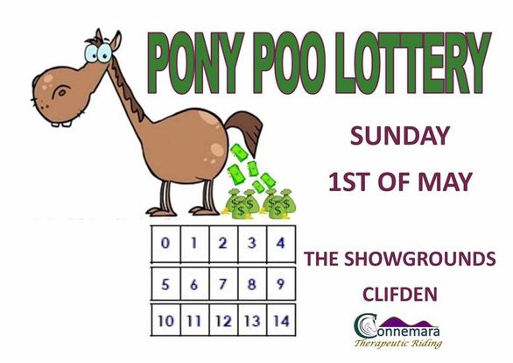

$20 a ticket.

Grand Prize $1000

Contact the office to buy a ticket for this year’s Fete’s Pony Poo Lotto.  Each square costs $20, if the pony poos in your square you take out the $1000 prize.

Get in early to secure the number square you want!

**Student Reports**

**Gr 5-6 Production**

Last term the 5/6s rounded up a term of drama with an incredible performance at the Avenel Hall of Wind in the Willows.  The students (thespians) were absolutely fantastic, and the musical received rave reviews from its audience. Production is an integral part of our Performing Arts curriculum and is so much more than just the final performance.

Students vying for a main role underwent an audition process, where they had to memorise a section of the script and perform it to a panel, they also had to have a singing audition.  From here students were selected by the senior teachers to fill the roles of the production, then each cast member was expected to memorise all their lines to not only the script but to every song. Rehearsals began as did song choreography. So many skills were developed in relation to acting, voice projections, gestures, use of stage, body language and facial expressions to name a few.  Literacy skills were built in how to read and follow a script as well as techniques for memorisation and the importance of expression and tone. We also focused on how to work as a team, commitment, follow through, support, acceptance and encouragement.

This is the largest cast of 5/6s to work together to put on the biannual performance and they were simply fantastic, a memory that we hope will live with them for their lifetime.

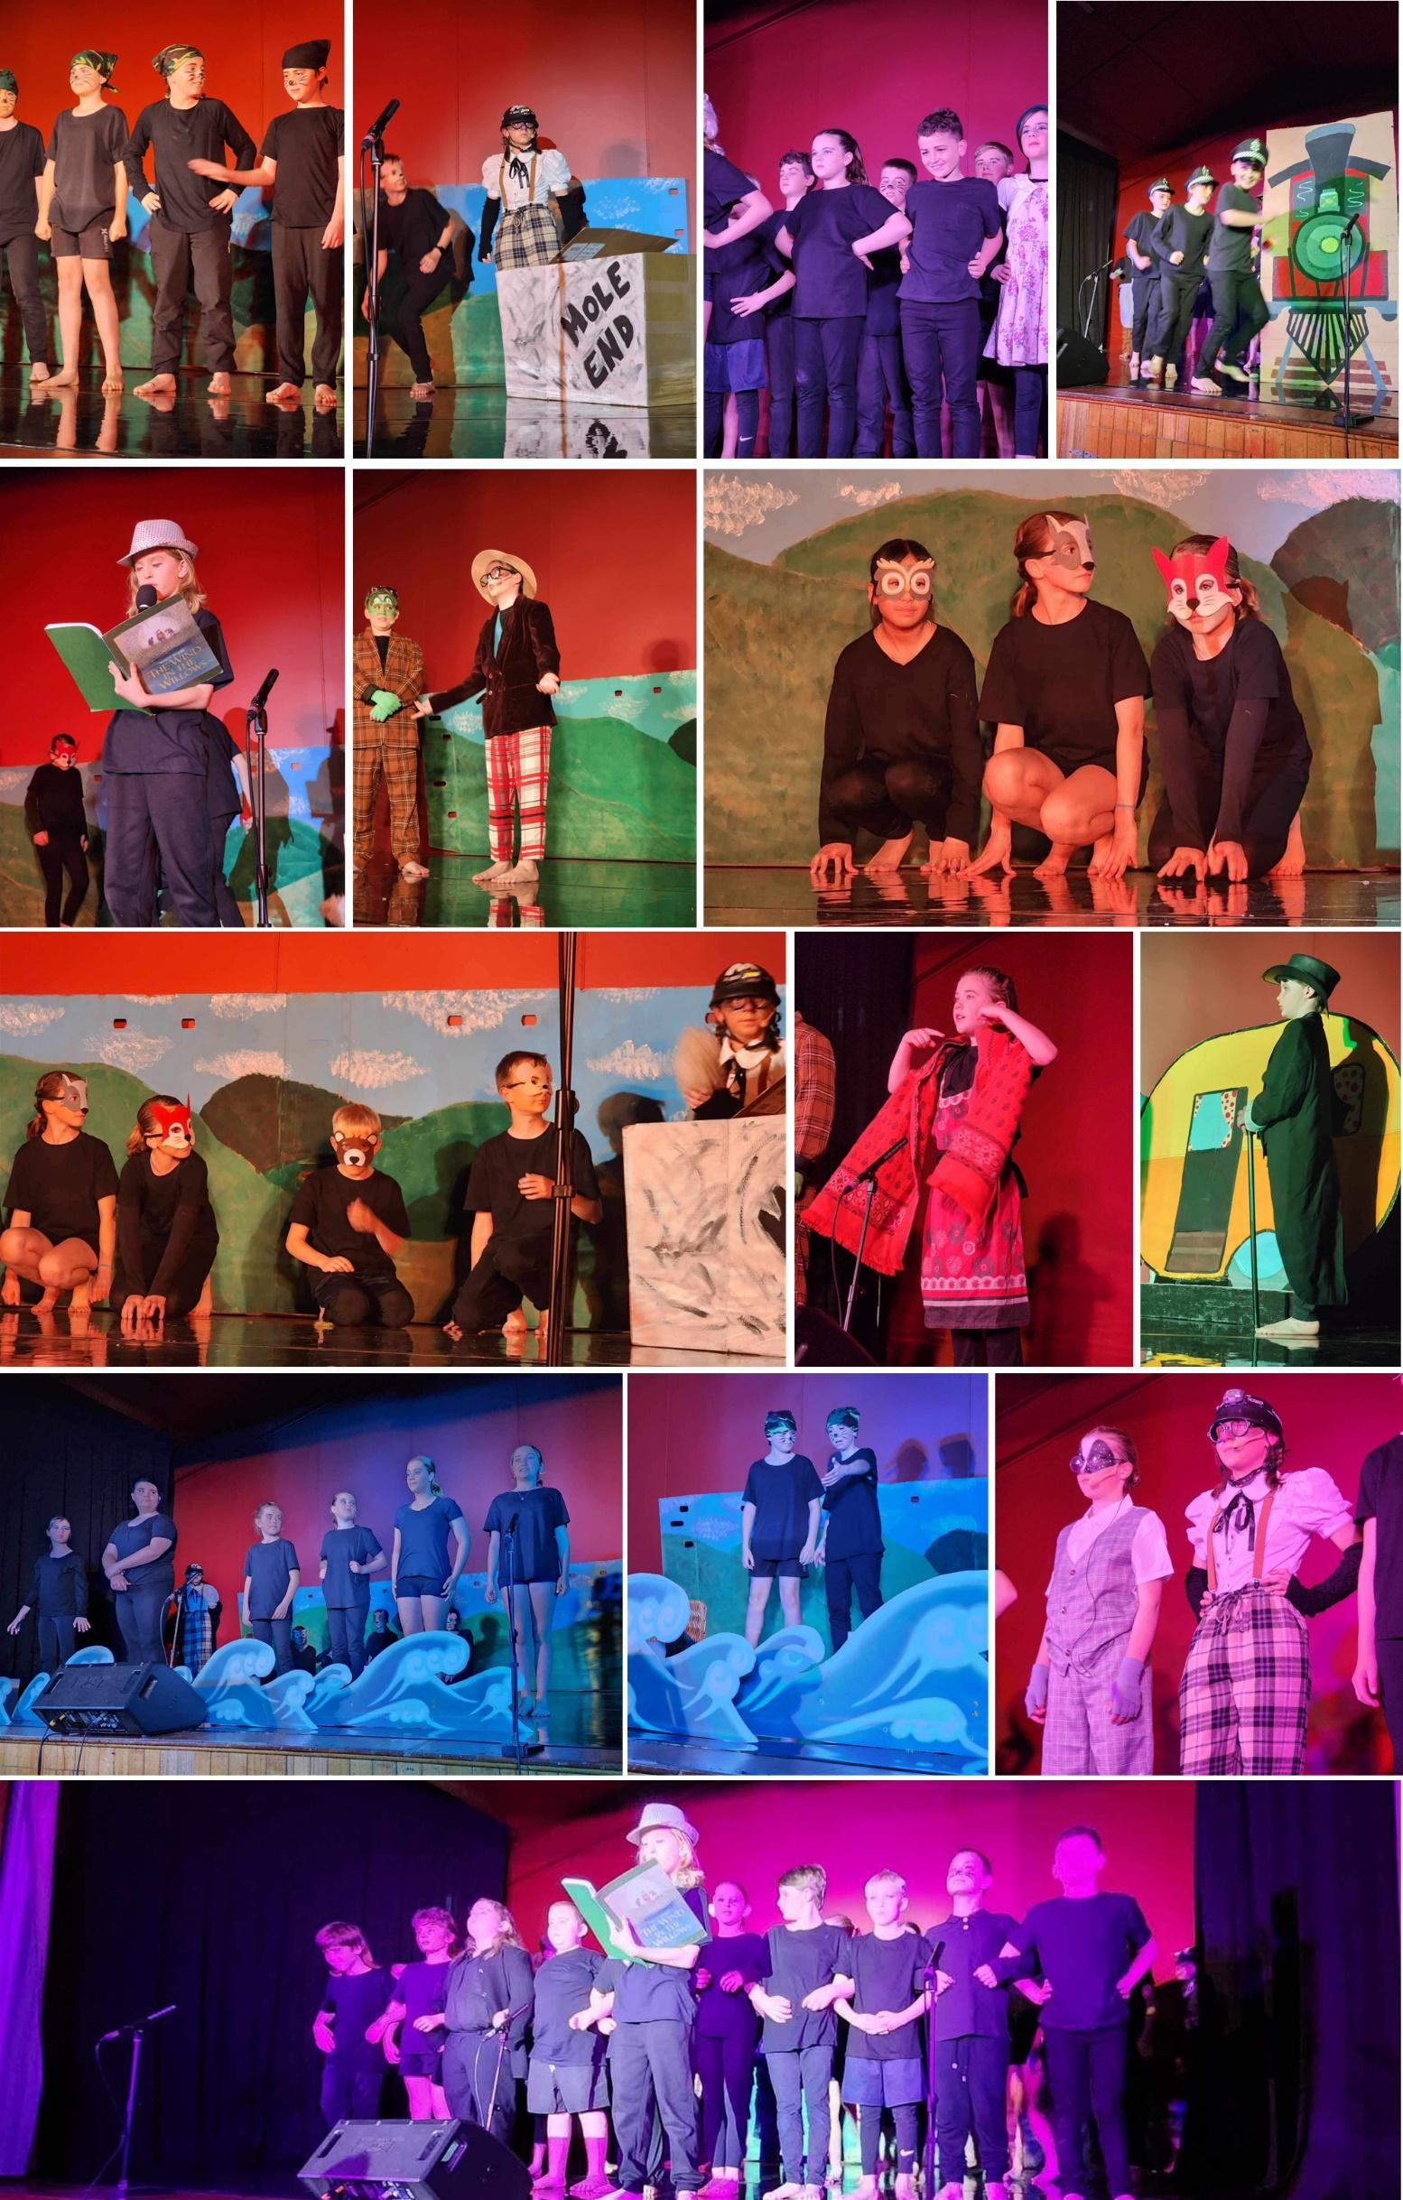

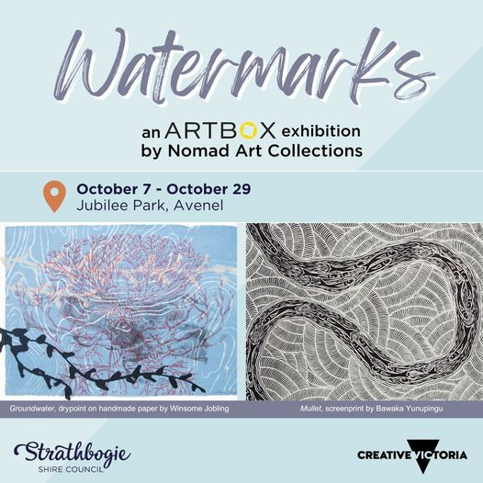

Nagambie Little Athletics - Registrations open!

Season will commence on Saturday 21st October 9am at St Joseph’s Primary School in Nagambie

[www.lavic.com.au/membership](https://aus01.safelinks.protection.outlook.com/?url=http%3A%2F%2Fwww.lavic.com.au%2Fmembership&data=05%7C01%7CDee.Wright%40education.vic.gov.au%7C447367ee049e4c41487708dbc3ac86c9%7Cd96cb3371a8744cfb69b3cec334a4c1f%7C0%7C0%7C638318917988241822%7CUnknown%7CTWFpbGZsb3d8eyJWIjoiMC4wLjAwMDAiLCJQIjoiV2luMzIiLCJBTiI6Ik1haWwiLCJXVCI6Mn0%3D%7C3000%7C%7C%7C&sdata=BHBv23xn4FET2OnEdbFJ6v5ZtGVWBnXLfgwuaGe6MGE%3D&reserved=0)

Clare Garrett – 0439 269 182

Facebook – Nagambie Little Athletics

**NEW ARTBOX EXHIBITION IN AVENEL**

Watermarks from [Nomad Art](https://www.facebook.com/nomadartgallery?__cft__%5b0%5d=AZW-crem6a6p1tRTPPFmsYNWYC-s7i9NKQMbwIMGLQUwCEF-dme_dz9jMONFWgqL0XYvP_75ap69tTCs77mOuyK4uKnpr9kqY3cmOJ896TnvAlwn2aRHTaPCN82N6FwNlLA_PBegW6k6f475oSguwmvuTwAmkPx6BcZ5rY6vST3H-x9EwJvHl_Y0BVy31HmkVNw&__tn__=-%5dK-R) Collections in Avenel looks at the diverse ways artists explore the notion of water. The works are drawn from artists nationally and range from depictions of the sea, living water in the desert, ceremonial associations and environmental perspectives.

Watermarks includes a selection of screenprints, etchings and linocuts. The artists include Candy Nakamarra – Central Australia, Helicopter Joe Tjungurrayi – Great Sandy Desert, Bawaka Yunupingu – East Arnhem Land, Laurie Nona – Far North Queensland, Ezarahia Kelly – West Arnhem Land, John Wolseley ­– Bendigo and Winsome Jobling – Darwin.

The Watermarks exhibition can be viewed through the glass windows at any time, and will be open during the following sessions:

Saturday October 7, 10.30am – 1pm

Sunday 8 October (Avenel Market), 9am – 1pm

October 14-15, 10am – 1pm

October 21-22, 10am – 1pm

Other times, by appointment

**JUNIOR CRICKET AND WOOLWORTHS CRICKET BLAST UPDATE!**

The Woolworths Cricket Blast program will begin on the **12th October - 23rd November!** This is a fantastic introduction for beginners aged 5-10. All children can be registered through <https://play.cricket.com.au/play/cricket-blast/woolworths-cricket-blast>.

We warmly encourage all students who share a love of cricket and team sport to come down and have a go. We are always seeking involvement from parents to help assist and coordinate the kids on training and match day. If you feel that you can help out in any way then please don’t hesitate to have a conversation with us on Thursday!

Keep an eye on the Avenel Cricket Club Facebook page and the newsletter for updates and information on the upcoming season!

If you are unable to make it and wish to talk further about the up and coming junior season please contact Gus Leunig 0421805027 Jamie Kanters 0409500762

**Community Information**

